- List the first and last names of all employees who draw less than or equal to $90,000 AND are NOT:
SELECT f_name, l_name
FROM employee_data
WHERE salary <= 90000
AND title NOT LIKE '%Programmer%';
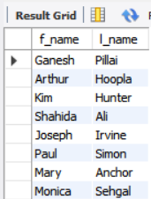
- What is displayed by this statement?
SELECT l_name, f_name
FROM employee_data
WHERE title NOT LIKE '%marketing%'
AND age < 30;
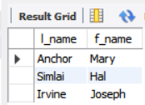
- List all IDs and names of all employees between 32 and 40 years of age.
SELECT id, f_name, l_name
FROM employee_data
WHERE age >= 32 AND age <= 40;
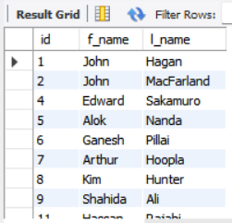

- Select names of all employees who are 32 years of age AND are NOT programmers.
SELECT f_name, l_name
FROM employee_data
WHERE age = 32
AND title NOT LIKE '%Programmer%';
